CREATE TABLE claroom(

building int,

room_number int,

capacity int,

PRIMARY KEY(building, room_number)

);

CREATE TABLE department(

dept_name varchar(20),

building varchar(20),

budget int,

PRIMARY KEY(dept_name)

);

Insert

INSERT INTO department(dept_name,building, budget)

VALUES ('CSE', 1, 1000000);

CREATE TABLE course(

couse_id int PRIMARY KEY,

title varchar(50),

dept_name varchar(20),

credits int

);

Insert

INSERT INTO course(course_id,title, dept_name, credits)

VALUES(210,'database','cse',15);

CREATE TABLE instructor(

ID int PRIMARY KEY,

Name varchar(20),

dept_name varchar(20),

salary int

);

Insert

INSERT INTO instructor (ID, Name, dept_name,salary)

VALUES(125,'salma','cse',40000);

CREATE TABLE teacher(

Id int ,

course_id int ,

sec_id int ,

semester int,

year int,

PRIMARY KEY(Id , course_id ,sec_id , semester , year,)

);

CREATE TABLE stu(

Id int,

name varchar(20),

dept_name varchar(23),

tot_cred int ,

PRIMARY KEY(id , name(20), dept_name(23),tot_cred)

);

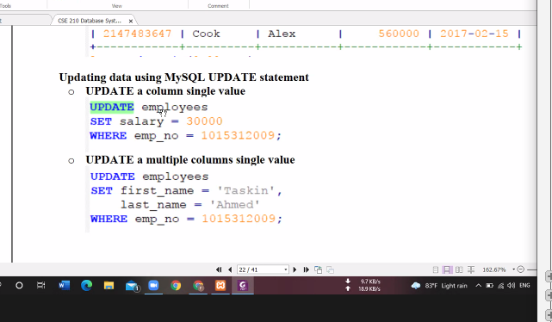

CREATE TABLE stude(

Id int(10) ,

name varchar(50),

email varchar(20)

);

Add:

ALTER TABLE stude ADD COLUMN address varchar(50) AFTER name;

ALTER TABLE stude ADD COLUMN phone varchar(50) AFTER address;

Backup:

CREATE TABLE IF NOT EXISTS stude_backup SELECT * FROM stude;CREATE TABLE teach(

tea_id int(10) ,

tea_dept varchar(50),

update:

UPDATE stude SET id=101 , name= "jakirul", address= "dhaka" , phone=123, email="jakiru@gamil.com";

email varchar(20)

);

Change:

ALTER TABLE stude CHANGE COLUMN id id int(10) PRIMARY key;

Add:

ALTER TABLE teach ADD COLUMN address varchar(50) AFTER tea_id;

ALTER TABLE teach ADD COLUMN name varchar(50) AFTER tea_id;

Backup:

CREATE TABLE IF NOT EXISTS teach_backup SELECT * FROM teach;

Update:

UPDATE teach SET tea_id=1077 , name= "sadia", address= "mirpur" , tea_dept="cse", email="sadia.com";

Change:

ALTER TABLE teach CHANGE COLUMN tea_id tea_id int(10) PRIMARY key;

CREATE TABLE employees(

emp_no int not null,

birth_date DATE not null,

first_name varchar(15) not null,

last_name varchar(15) not null ,

gender ENUM ('M') not null,

salary int not null,

entry_date datetime not null,

PRIMARY KEY (emp_no)

);

INSERT into employees (emp_no , birth_date,first_name ,last_name, gender,salary)

VALUES(109 , '1998-08-28' , 'sakib','rahman','M',40000),

(110 , '1798-08-18' , 'newclass','rahman','M',40700),

(111 , '1988-08-28' , 'mahmud','rahmn','M',45000);

Searching:  
SELECT * FROM `employees` WHERE salary >= 45000 ;